**Biology Revision: Blood and the Heart**

Mastery Matrix Points

|  |
| --- |
| Describe the structure and function of the human heart |
| Describe the roles of the four blood vessels associated with the heart |
| Describe the 3 different types of blood vessel in the body and their structure |
| Carry out rate calculations for blood flow |
| Describe how our body controls our natural resting heart rate |
| Describe the composition of blood and know the functions of each of the components |
| Draw blood cells from under a microscope and recognise different types of blood cells from a photo or diagram, explaining how they are adapted to their functions |
| Describe coronary heart disease |
| Describe what a ‘stent’, ‘statin’, ‘mechanical/biological valve replacement’, ‘pacemaker’ and ‘transplant’ are |
| Evaluate the advantages and disadvantages of treating cardiovascular diseases using drugs, mechanical devices or transplants |
| Evaluate risks associated with the use of blood products |

Key Knowledge

What are the roles of these parts of the heart?

*Vena cava –*

*Pulmonary artery –*

*Pulmonary vein –*

*Aorta –*

Which part of the heart contains the cells that are the body’s natural pacemaker?

|  |  |  |
| --- | --- | --- |
| *Blood vessel* | *Job* | *adaptations* |
| Artery |  |  |
| Vein |  |  |
| Capillary |  |  |

Rate of blood flow =

Four parts of the blood and their function:



Definition of coronary heart disease:

What are:

* Stents?
* Statins?
* Pacemaker?
* Transplant?

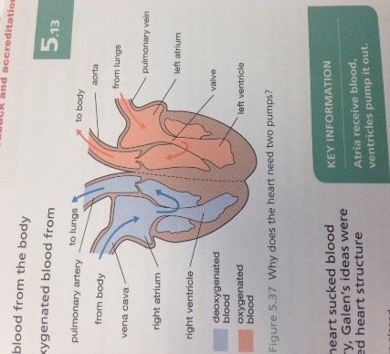

**A**

**B**

**C**

**D**

**E**

**F**

**G**

**H**

**I**

Understanding and Explaining

1. Explain how the heart works including the route the blood travels through and where the blood flows.
2. Which side of the heart is more muscular? Explain why.
3. Calculate the cardiac output of the heart if the stroke volume is 50cm3 and the heart rate is 67bpm?
4. Label the components of blood on this microscope photo.

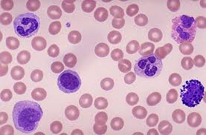

1. Evaluate the risks of having a blood transfusion.
2. Explain what coronary heart disease is. Explain the causes and effects too.
3. Evaluate the four ways to treat heart conditions. Give a pro and con for each.